[Home - InstructionalDesign.org](https://www.instructionaldesign.org/)

**Instructional Design Models**

The following is a list of prescriptive instructional design models. Prescriptive models provide guidelines or frameworks to organize and structure the process of creating instructional activities. These models can be used to guide your approach to the art or science (your choice) of instructional design. The following are commonly accepted prescriptive design models:

* 4C-ID Model(Jeroen van Merriënboer)
* Algo-Heuristic Theory (Lev Landa)
* [ADDIE Model](http://instructionaldesign.org/models/addie/)
  + [Weaknesses of the ADDIE model](http://instructionaldesign.org/models/addie_weaknesses/)
* [ARCS](http://instructionaldesign.org/models/arcs/) (John Keller)
* [ASSURE](http://instructionaldesign.org/models/assure/) (Heinich, Molenda, Russel, and Smaldino)
* [Backward Design](http://instructionaldesign.org/models/backward_design/) (Wiggins & McTighe)
* [Cognitive Apprenticeship](https://www.instructionaldesign.org/models/cognitive-apprenticeship/) (Edmondson)
* Conditions of Learning (Robert Gagne)
* Component Display Theory (David Merrill)
* Criterion Referenced Instruction(Robert Mager)
* [Dick and Carey](http://instructionaldesign.org/models/dick_carey_model/)
* Elaboration Theory
* [Gerlach-Ely Model](http://edutechwiki.unige.ch/en/Gerlach_and_Ely_design_model)
* Hannafin-Peck Model
* Kirk and Gustafson Model
* Instructional Systems Design ISD
* Integrative Learning Design Framework for Online Learning (Debbaugh)
* [Iterative Design](http://instructionaldesign.org/models/iterative_design/)
  + [Spiral Model](http://instructionaldesign.org/models/spiral_model/) (Boehm)
  + [Rapid Prototyping](http://instructionaldesign.org/models/rapid_prototyping/) (Tripp & Bichelmeyer)
* [Kemp Design Model](http://instructionaldesign.org/models/kemp_model/) (Morrison, Ross, and Kemp)
* Organizational Elements Model(OEM) (Roger Kaufman)
* [Transactional Distance](http://instructionaldesign.org/models/transactional_distance/) (Michael Moore)
* Cognitive Apprenticeship
* Discovery Learning
* Empathic instructional design
* Goal-based scenarios

**Objective Taxonomies**

* Cognitive Domain(Benjamin Bloom)
* Affective Domain(David Krathwohl)
* Psycho-motor Domain(Elizabeth Jane Simpson)

**Learning Concepts**



Click here for a [Glossary of Instructional Design Terms](http://instructionaldesign.org/concepts/glossary/)

* Adaptive Learning
* [Anxiety](http://instructionaldesign.org/concepts/anxiety/)
* [Arousal](http://instructionaldesign.org/concepts/arousal/)
* [Assessment](http://instructionaldesign.org/concepts/assessment/)
* [Attention](http://instructionaldesign.org/concepts/attention/)
* [Attitudes](http://instructionaldesign.org/concepts/attitudes/)
* [Cognitive Styles](http://instructionaldesign.org/concepts/cognitive-styles/)
* [Competency based learning](http://instructionaldesign.org/concepts/competency-based-learning/)
* [Creativity](http://instructionaldesign.org/concepts/creativity/)
* [Differentiated learning](http://instructionaldesign.org/concepts/differentiated-learning/)
* [Grit and Persistence](http://instructionaldesign.org/concepts/grit/)
* [GUI Design](http://instructionaldesign.org/concepts/gui_design/)
* [Human Computer Interaction (HCI)](http://instructionaldesign.org/concepts/hci/)
* [Imagery](http://instructionaldesign.org/concepts/imagery/)
* [Individualized Learning](http://instructionaldesign.org/concepts/individualized-learning/)
* [Learning Objects](http://instructionaldesign.org/concepts/learning_objects/)
* [Learning Strategies](http://instructionaldesign.org/concepts/learning-strategies/)
* [Mastery](http://instructionaldesign.org/concepts/mastery/)
* [Memory](http://instructionaldesign.org/concepts/memory/)
* [Mental Models](http://instructionaldesign.org/concepts/mental-models/)
* [Metacognition](http://instructionaldesign.org/concepts/metacognition/)
* [Motivation](http://instructionaldesign.org/concepts/motivation/)
* [Personalized Learning](http://instructionaldesign.org/concepts/personalized-learning/)
* [Productions](http://instructionaldesign.org/concepts/productions/)
* [Reinforcement](http://instructionaldesign.org/concepts/reinforcement/)
* [Schema](http://instructionaldesign.org/concepts/schema/)
* [Sequencing of Instruction](http://instructionaldesign.org/concepts/sequence-instruction/)
* [Storyboarding](http://instructionaldesign.org/concepts/storyboarding/)
* [Storyboard Software](http://instructionaldesign.org/concepts/storyboard_software/)
* [Taxonomies](http://instructionaldesign.org/concepts/taxonomies/)
* [Usability Testing](http://instructionaldesign.org/concepts/usability_testing/)

**Learning Theories**

* [ACT-R](http://instructionaldesign.org/theories/act/) (John Anderson)
* [Adult Learning Theory](http://instructionaldesign.org/theories/adult-learning/) (P. Cross)
* [Algo-Heuristic Theory](http://instructionaldesign.org/theories/algo-heuristic/) (L. Landa)
* [Andragogy](http://instructionaldesign.org/theories/andragogy/) (Malcolm Knowles)
* [Anchored Instruction](http://instructionaldesign.org/theories/anchored-instruction/) (John Bransford)
* [Aptitude-Treatment Interaction](http://instructionaldesign.org/theories/aptitude-treatment/) (L. Cronbach & R. Snow)
* [Attribution Theory](http://instructionaldesign.org/theories/attribution-theory/) (B. Weiner)
* [Cognitive Dissonance Theory](http://instructionaldesign.org/theories/cognitive-dissonance/) (L. Festinger)
* [Cognitive Flexibility Theory](http://instructionaldesign.org/theories/cognitive-flexibility/) (R. Spiro)
* [Cognitive Load Theory](http://instructionaldesign.org/theories/cognitive-load/) (J. Sweller)
* [Component Display Theory](http://instructionaldesign.org/theories/component-display/) (M. David Merrill)
* [Conditions of Learning](http://instructionaldesign.org/theories/conditions-learning/) (Robert Gagne)
* [Connectionism](http://instructionaldesign.org/theories/connectionism/) (Edward Thorndike)
* [Constructivist Theory](http://instructionaldesign.org/theories/constructivist/) (Jerome Bruner)
* [Contiguity Theory](http://instructionaldesign.org/theories/contiguity-theory/) (Edwin Guthrie)
* [Conversation Theory](http://instructionaldesign.org/theories/conversation-theory/) (Gordon Pask)
* [Criterion Referenced Instruction](http://instructionaldesign.org/theories/criterion-referenced/) (Robert Mager)
* [Double Loop Learning](http://instructionaldesign.org/theories/double-loop/) (C. Argyris)
* [Drive Reduction Theory](http://instructionaldesign.org/theories/drive-reduction/) (C. Hull)
* [Dual Coding Theory](http://instructionaldesign.org/theories/dual-coding/) (A. Paivio)
* [Elaboration Theory](http://instructionaldesign.org/theories/elaboration-theory/) (C. Reigeluth)
* [Experiential Learning](http://instructionaldesign.org/theories/experiential-learning/) (C. Rogers)
* [Functional Context Theory](http://instructionaldesign.org/theories/functional-context/) (Tom Sticht)
* [Genetic Epistemology](http://instructionaldesign.org/theories/genetic-epistemology/) (J. Piaget)
* [Gestalt Theory](http://instructionaldesign.org/theories/gestalt/) (M. Wertheimer)
* [GOMS](http://instructionaldesign.org/theories/goms/) (Card, Moran & Newell)
* [General Problem Solver](http://instructionaldesign.org/theories/general-problem-solver/) (A. Newell & H. Simon)
* [Information Pickup Theory](http://instructionaldesign.org/theories/information-pickup/) (J.J. Gibson)
* [Information Processing Theory](http://instructionaldesign.org/theories/information-processing/) (G.A. Miller)
* [Lateral Thinking](http://instructionaldesign.org/theories/lateral-thinking/) (E. DeBono)
* [Levels of Processing](http://instructionaldesign.org/theories/levels-processing/) (Craik & Lockhart)
* [Mathematical Learning Theory](http://instructionaldesign.org/theories/mathematical-learning/) (R.C. Atkinson)
* [Mathematical Problem Solving](http://instructionaldesign.org/theories/mathematical/) (A. Schoenfeld)
* [Minimalism](http://instructionaldesign.org/theories/minimalism/) (J. M. Carroll)
* [Model Centered Instruction and Design Layering](http://instructionaldesign.org/theories/design-layers/) (Andrew Gibbons)
* [Modes of Learning](http://instructionaldesign.org/theories/modes-learning/) (D. Rumelhart & D. Norman)
* [Multiple Intelligences](http://instructionaldesign.org/theories/multiple-intelligences/) (Howard Gardner)
* [Operant Conditioning](http://instructionaldesign.org/theories/operant-conditioning/) (B.F. Skinner)
* [Originality](http://instructionaldesign.org/theories/originality/) (I. Maltzman)
* [Phenomenonography](http://instructionaldesign.org/theories/phenomenography/) (F. Marton & N. Entwistle)
* [Repair Theory](http://instructionaldesign.org/theories/repair-theory/) (K. VanLehn)
* [Script Theory](http://instructionaldesign.org/theories/script-theory/) (Roger Schank)
* [Sign Theory](http://instructionaldesign.org/theories/sign-theory/) (E. Tolman)
* [Situated Learning](http://instructionaldesign.org/theories/situated-learning/) (J. Lave)
* [Soar](http://instructionaldesign.org/theories/soar/) (A. Newell et al.)
* [Social Development](http://instructionaldesign.org/theories/social-development/) (L. Vygotsky)
* [Social Learning Theory](http://instructionaldesign.org/theories/social-learning/) (A. Bandura)
* [Stimulus Sampling Theory](http://instructionaldesign.org/theories/stimulus-sampling/) (W. Estes)
* [Structural Learning Theory](http://instructionaldesign.org/theories/structural-learning/) (J. Scandura)
* [Structure of Intellect](http://instructionaldesign.org/theories/intellect/) (J. Guilford)
* [Subsumption Theory](http://instructionaldesign.org/theories/subsumption-theory/) (D. Ausubel)
* [Symbol Systems](http://instructionaldesign.org/theories/symbol-systems/) (G. Salomon)
* [Triarchic Theory](http://instructionaldesign.org/theories/triarchic-theory/) (R. Sternberg)
* [Transformational Learning](http://instructionaldesign.org/theories/transformative-learning/) (J. Mezirow)

**Learning Domains**

Explore learning domains:

* [Aviation](http://instructionaldesign.org/domains/aviation/)
* [Computers](http://instructionaldesign.org/domains/computers/)
* [Concepts](http://instructionaldesign.org/domains/concept-learning/)
* [Decision Making](http://instructionaldesign.org/domains/decision-making/)
* [Engineering](http://instructionaldesign.org/domains/engineering/)
* [Language](http://instructionaldesign.org/domains/language/)
* [Management](http://instructionaldesign.org/domains/management/)
* [Mathematics](http://instructionaldesign.org/domains/math/)
* [Medicine](http://instructionaldesign.org/domains/medicine/)
* [Military](http://instructionaldesign.org/domains/military/)
* [Perception](http://instructionaldesign.org/domains/perception/)
* [Problem Solving](http://instructionaldesign.org/domains/problem-solving/)
* [Procedures](http://instructionaldesign.org/domains/procedures/)
* [Reading](http://instructionaldesign.org/domains/reading/)
* [Reasoning](http://instructionaldesign.org/domains/reasoning/)
* [Sales](http://instructionaldesign.org/domains/sales/)
* [Sensory-Motor](http://instructionaldesign.org/domains/sensory-motor/)
* [Troubleshooting](http://instructionaldesign.org/domains/troubleshooting/)

**Instructional Design Books**

**Explore by Category:**

* [All](https://www.instructionaldesign.org/books)
* [Curriculum Design](https://www.instructionaldesign.org/category/curriculum-design/)
* [General Design Principles](https://www.instructionaldesign.org/category/general-design-principles/)
* [Graphic Design](https://www.instructionaldesign.org/category/graphic-design/)
* [Instructional Design](https://www.instructionaldesign.org/category/instructional-design/)
* [Learning Theory](https://www.instructionaldesign.org/category/learning-theory/)
* [Uncategorized](https://www.instructionaldesign.org/category/uncategorized/)
* [Usability/Web Design](https://www.instructionaldesign.org/category/usability-web-design/)

[**Ten Steps to Complex Learning: A Systematic Approach to Four-Component Instructional Design 3rd Edition**](https://www.instructionaldesign.org/books/ten-steps-to-complex-learning-a-systematic-approach-to-four-component-instructional-design-3rd-edition/)

[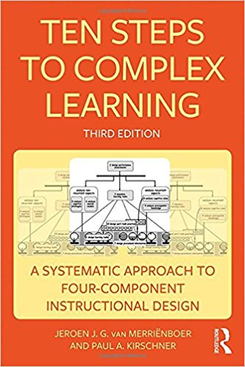](https://www.instructionaldesign.org/books/ten-steps-to-complex-learning-a-systematic-approach-to-four-component-instructional-design-3rd-edition/)

[**Basics of Instructional Systems Development**](https://www.instructionaldesign.org/books/basics-of-instructional-systems-development/)

[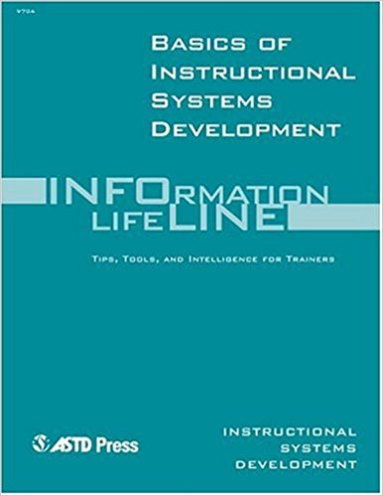](https://www.instructionaldesign.org/books/basics-of-instructional-systems-development/)

[**Principles of Instructional Design 5th Edition**](https://www.instructionaldesign.org/books/principles-of-instructional-design-5th-edition/)

[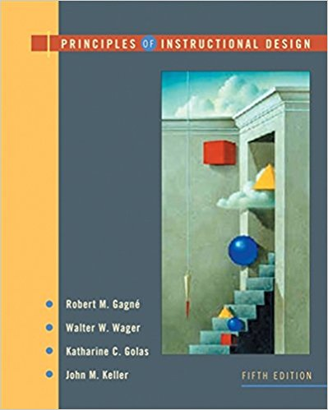](https://www.instructionaldesign.org/books/principles-of-instructional-design-5th-edition/)

[**Instructional Design 3rd Edition**](https://www.instructionaldesign.org/books/instructional-design-3rd-edition/)

[**Design for How People Learn (2nd Edition)**](https://www.instructionaldesign.org/books/design-for-how-people-learn-2nd-edition/)

[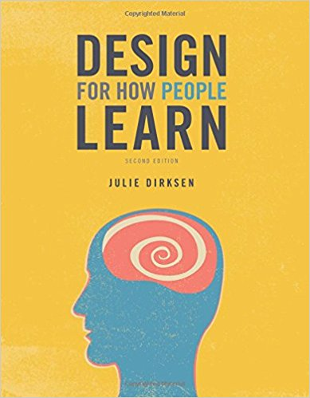](https://www.instructionaldesign.org/books/design-for-how-people-learn-2nd-edition/)

[**Designing Effective Instruction 7th Edition**](https://www.instructionaldesign.org/books/designing-effective-instruction-7th-edition/)

[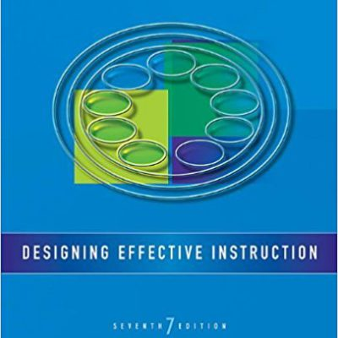](https://www.instructionaldesign.org/books/designing-effective-instruction-7th-edition/)

[**Trends and Issues in Instructional Design and Technology (4th Edition)**](https://www.instructionaldesign.org/books/trends-and-issues-in-instructional-design-and-technology-4th-edition/)

[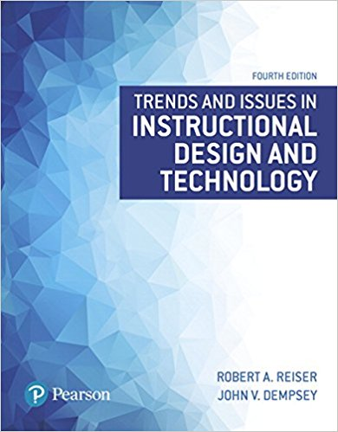](https://www.instructionaldesign.org/books/trends-and-issues-in-instructional-design-and-technology-4th-edition/)

[**Learning to Solve Problems: An Instructional Design Guide**](https://www.instructionaldesign.org/books/learning-to-solve-problems-an-instructional-design-guide/)

[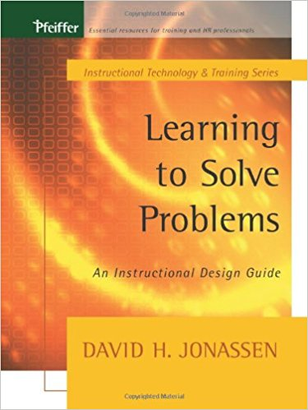](https://www.instructionaldesign.org/books/learning-to-solve-problems-an-instructional-design-guide/)

[**Web-Based Learning: Design, Implementation and Evaluation, 2nd Edition**](https://www.instructionaldesign.org/books/web-based-learning-design-implementation-and-evaluation-2nd-edition/)

[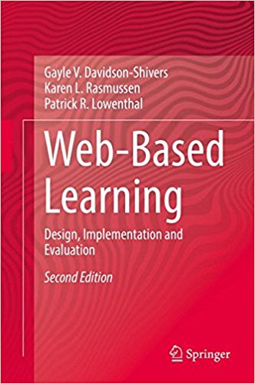](https://www.instructionaldesign.org/books/web-based-learning-design-implementation-and-evaluation-2nd-edition/)

[**The Art of Interactive Design: A Euphonious and Illuminating Guide to Building Successful Software**](https://www.instructionaldesign.org/books/the-art-of-interactive-design-a-euphonious-and-illuminating-guide-to-building-successful-software/)

[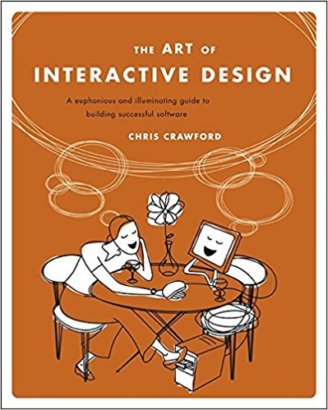](https://www.instructionaldesign.org/books/the-art-of-interactive-design-a-euphonious-and-illuminating-guide-to-building-successful-software/)

[**The Innovator’s Mindset: Empower Learning, Unleash Talent, and Lead a Culture of Creativity**](https://www.instructionaldesign.org/books/the-innovators-mindset-empower-learning-unleash-talent-and-lead-a-culture-of-creativity/)

[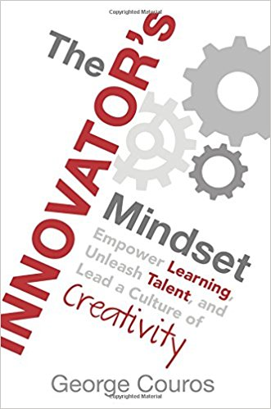](https://www.instructionaldesign.org/books/the-innovators-mindset-empower-learning-unleash-talent-and-lead-a-culture-of-creativity/)

[**Small Teaching: Everyday Lessons from the Science of Learning**](https://www.instructionaldesign.org/books/small-teaching-everyday-lessons-from-the-science-of-learning/)

[](https://www.instructionaldesign.org/books/small-teaching-everyday-lessons-from-the-science-of-learning/)